July 2022

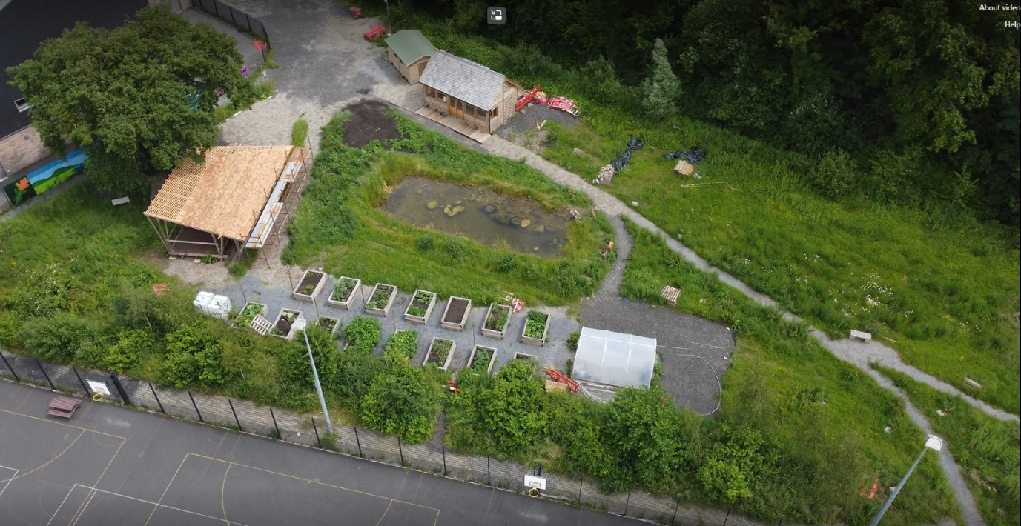
How Natur has grown

In 2021, we introduced you to Natur, a visionary outdoor learning area at Ysgol Bro Dinefwr, Llandeilo that was in the planning stages. We recently caught up with the school’s Assistant Headteacher, Ian Chriswick, to find out how it has developed over the last year.

Ian was pleased to report that the outdoor learning area is flourishing, with 15 raised vegetable beds and a polytunnel that has allowed pupils to enjoy gathering their first harvest from the area. The plants are looked after by the school’s horticulture club which meets weekly to learn horticulture skills from two visiting members of the National Botanic Gardens of Wales.

The botanic gardeners are really excited to be involved with Natur, believing that gardening and outdoor learning inspires children to become the conservationists and environmentalists of the future. They are keen for other schools to develop their own gardens because learning about nature as children helps people to care for nature throughout their life.

With the help of the gardeners, the horticulture club has planted 44 fruit trees around the school site. The trees were funded by Social Farms and Gardens, who will also supply over £4,000 of processing equipment that will enable pupils to learn how to turn their harvest into jams, chutneys and juices during food and nutrition lessons when the trees mature.

Expressive arts in the outdoors

Natur is home to a newly completed outdoor performance stage, designed and built by postgraduate students from the Centre for Alternative Technology (CAT) and decorated with pupils’ leaf prints. The stage will be a key way to link art, drama, music and dance to the natural environment and will host the school’s summer shows and Christmas concerts.
Ian said: “The idea is to get learners out into the middle of nature, performing expressive arts because it’s not just about teaching them how to grow vegetables, it’s about linking them with nature in as many ways as possible.”

Gathering environmental data

Working with the Royal Society, the school is installing two weather stations - one in Natur and the other adjacent to the main entrance to the carpark – and will use the data to look at pollution levels around their school. This data will be streamed live on the school website for various people to access.
The school also hopes to contribute its data to a project on river pollution with Coleg Sir Gar - Gelli Aur. The project aims to let farmers know the best time to spread silage on their fields, giving the school the opportunity to talk to pupils about how to protect water quality in rivers.

Pupils and staff feel the benefit

Ian reported that the outdoor learning area is having a positive impact on the well-being of its users: “The fact that the school’s youth worker has chosen to use it as her base says a lot. She says that the pupils are a lot more open because they are away from the main school site and not stuck in a monochrome classroom environment.”

The drama teacher has also commented on the difference in her pupils’ behaviour during the classes she held out there. And the children involved in the horticulture club say they feel happier, calmer and more creative when surrounded by nature, and have found designing the garden fun and rewarding. Working in the garden also helps them to develop independent learning and team working skills that are beneficial in all areas of life.
The school is recruiting a permanent outdoor learning technician who, along with managing building and maintenance on the site, will work with small groups of children who require an alternative to mainstream lessons in order to thrive.

Advice for other schools

Ysgol Bro Dinefwr hopes to have a positive impact on the county and build momentum for outdoor learning through the Carmarthenshire Climate Change Consultation Group which gives schools the opportunity to work together.

Ian’s advice for other schools looking to set up an outdoor learning area is to make sure they involve all stakeholders: “For this to be successful long-term, you have to have the community involved - you have to have parents who are aware of it, and you’ve got to bring the students with you as well - so it really has to be a collaborative movement.”
Ian’s other piece of advice is to get a funding model in place early on. One solution Ysgol Bro Dinefwr is exploring is to set up their PTA as a community interest company to allow it to apply for charity funding - something state-funded schools can’t do themselves.

Looking to the future

Small groups of pupils have enjoyed using Natur so far - but from September, after the entrance is completed, bigger groups of pupils and people from outside the school will be invited in to use the area too.

At the end of this school year, Ian is changing roles and will hand over the care of Natur to his successor, who is hoping to start a forest school in the adjacent woodland and rekindle projects delayed by Covid – such as 3D printing with beeswax. Longer term, the school aims to introduce the Built Environment GCSE as well as other qualifications related to outdoor learning.

Ian will be moving on to Gower College where he will lecture in horticulture, landscaping and eco construction while developing an even more ambitious outdoor learning area. Ian is also excited to be working with Cymbrogi Futures, taking sustainability education into secondary schools throughout Wales to inspire today’s pupils into the sustainability jobs of 2030.

Follow Ysgol Bro Dinefwr’s journey to develop Natur on Twitter.

Looking for learning resources, information or data? Please contact:
education@naturalresourceswales.gov.uk or go to https://naturalresources.wales/learning
Alternative format; large print or another language, please contact:
enquiries@naturalresourceswales.gov.uk
0300 065 3000

